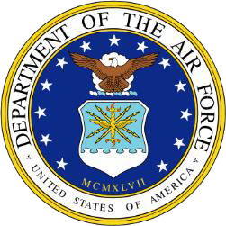
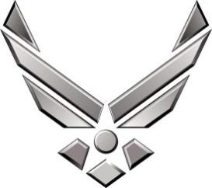
BIOGRAPHY
UNITED STATES AIR FORCE

CHIEF MASTER SERGEANT MICHAEL E. CORNITIUS JR.
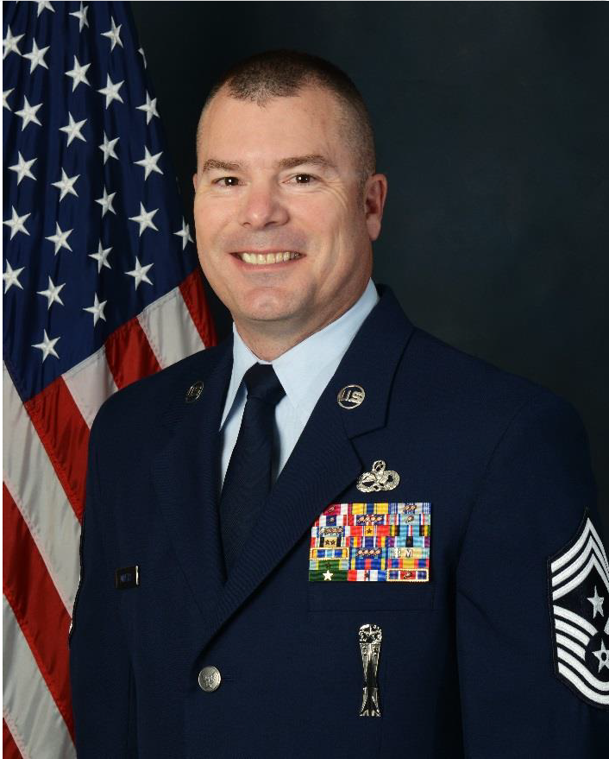
Chief Michael E. Cornitius Jr. is the 147th Attack Wing, Command Chief, Texas Air National Guard, Ellington Field Joint Reserve Base (JRB), Houston, Texas. He is the principal enlisted advisor to the commander for more than 800 assigned enlisted personnel. His responsibilities include advising the commander on all matters affecting the readiness, training, professional development and effective utilization of assigned enlisted personnel and coordinating with the headquarters staff, commanders, and senior personnel on administration and implementation of command policy.

Chief Cornitius entered the U.S. Air Force in 1988 and served as a certified Secure Communications Specialist. He was then assigned to the 1882nd Communications Squadron at Bergstrom Air Force Base, Texas. Without a break in service, Chief Cornitius enlisted in the Texas Air National Guard in 1991, and started his assignment as a traditional guardsman. He served on numerous deployments and homeland missions including CORONET NIGHTHAWK to Panama in 1997 and 1999, as well as Operations SOUTHERN WATCH in 2000 and NOBLE EAGLE in 2001. In addition, Chief deployed to Iraq twice, in 2005 and 2007, following the 9/11 attacks in support of Operation IRAQI FREEDOM. In 1995, Chief Cornitius was selected as a member of the Lead Standardization Team responsible for training all weapons load crews. Since then, he has held various positions to include Group Quality Assurance Weapons Inspector, Weapons Element Non-Commissioned Officer in Charge and Wing Weapons Manager. He was the direct link for the Air National Guard as the National Guard Bureau Systems Program Office Contact field representative for any weapons related issues on remotely piloted aircraft. He has been a member of the wing EET/WIT
Approximate Size: 3.2" x 4", High Res.
(See T&Q p. 259)
team since 2003 and in September 2013, he was lead for the wing’s first inspection under the new Air Force Inspection System coordinating essential aspects of the inspection with both internal and external inspectors. Prior to his current position, Chief Cornitius was the Aircraft Maintenance Flight Superintendent, 147th Maintenance Group, Ellington Field Joint Reserve Base, Houston, Texas.

Chief Cornitius has been employed with the Houston Fire Department for 24 years. As a City of Houston firefighter, he was selected by district chiefs to become one of the first Incident Command Technicians to work hand in hand with the chiefs on fire scenes in directing fire ground operations. He has also been an active member of the League City Volunteer Fire Department since 2001. In 2002, he was elected by the department membership to serve as a station captain responsible for the training of all members assigned to Station 5, and held this position for 11 years. Chief Cornitius belongs to numerous committees within the League City Fire Department with many of these contributing directly to the goals and career paths of the department and personnel.

EDUCATION
1994 | Non-commissioned Officer Leadership School, Maxwell-Gunter Air Force Base, Ala.
2002 | Non-Commissioned Officer Academy, Maxwell AFB, Ala., by correspondence
2005 | Senior Non-Commissioned Officer Academy, Maxwell AFB, Ala., by correspondence
2013 | Air National Guard Chief’s Executive Course, Joint Base Andrews, Md.
2015 | Associate of Applied Science, Aircraft Armament Systems Technology, CCAF
2015 | Senior Enlisted Joint Professional Military Education Course I, Maxwell AFB, Ala., by correspondence

2016 | Air National Guard Command Chief Master Sergeant Orientation Course, Lackland AFB, Texas
2016 | Texas Adjutant General Leadership Development Program, Camp Mabry, Austin
2017 | Enterprise Leadership Seminar, University of North Carolina, Chapel Hill
2017 | Continuous Process Improvement for Executives, Duke University, N.C.

ASSIGNMENTS
- November 1988–January 1989, USAF Basic Training, Lackland Air Force Base, Texas
- January 1989–September 1989, USAF Technical School, Lackland AFB, Texas
- September 1989–December 1991, USAF 1882nd Communications Squadron, TAC, Bergstrom AFB, Texas
- December 1991–April 2015, 147th Reconnaissance Wing, ACC, Ellington JRB, Texas
- April 2015–Present, Command Chief, 147th Attack Wing, Ellington JRB, Texas

MAJOR AWARDS AND DECORATIONS
Air Force Meritorious Service Medal with oak leaf cluster
Air Force Commendation Medal
Air Force Achievement Medal with two oak leaf clusters Meritorious Unit Award with oak leaf cluster
AF Outstanding Unit Award with four oak leaf clusters AF Good Conduct Medal with oak leaf cluster
Air Reserve Forces Meritorious Service Medal with eight oak leaf clusters National Defense Service Medal with bronze service star
Armed Forces Expeditionary Medal
Iraq Campaign Ribbon with two Bronze Service Stars Global War on Terrorism Service Medal
Humanitarian Service Medal with bronze service star Air Force Expeditionary Service Ribbon with gold border

STATE AWARDS AND DECORATIONS
Texas Combat Service Medal with bronze star Texas Medal of Merit
Texas Governor’s Unit Citation with oak leaf cluster Texas Adjutant Generals Individual Award

PROFESSIONAL MEMBERSHIPS AND ASSOCIATIONS
147th Attack Wing Chief Council 147th Attack Wing Top 3 Council
The National Guard Association of Texas, Life Member
Enlisted Association of the National Guard of the United States, Life Member Air Force Sergeants Association
Air Force Association
ANG CCM Alumni Association

EFFECTIVE DATES OF PROMOTION
Airman May 23, 1989
Airman First Class March 23, 1990
Senior Airman November 23, 1991
Staff Sergeant October 1, 1994
Technical Sergeant June 5, 1999
Master Sergeant September 7, 2002
Senior Master Sergeant February 20, 2008
Chief Master Sergeant November 15, 2011 (Current as of February 2018)

