PeopleTools 8.55 - Browser Information & Tips
Contents
Introduction 2
Clear Browser Cache 2
Internet Explorer 2
Google Chrome 4
Internet Explorer Settings 6
User sees Blank Screen 7

Introduction
This document contains Internet Browsers Information & Tips that are applicable to the PeopleTools 8.55 upgrade.

Clear Browser Cache
When alternating between multiple versions of PeopleTools on the same machine, your browser cookies may interfere with the rendering of pages and other functionality. It is recommended that you clear your browser cache.

Internet Explorer
The following are instructions for clearing cache if you are using Internet Explorer.

- Access your Tools menu, by clicking it from your Browser Menu Bar or by clicking on the Tools “Cog” in the top right corner of the window.

- Select Internet Options.

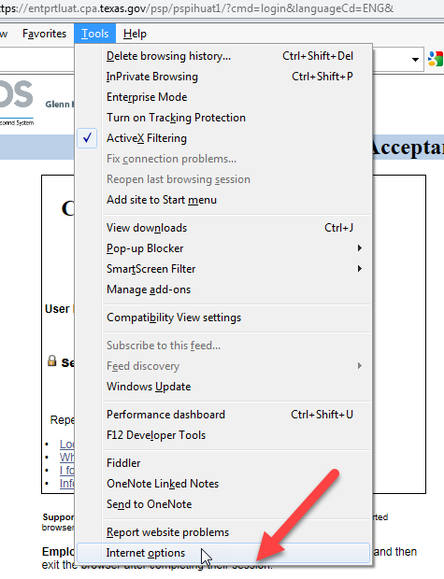

- Under the “General” Tab, check the checkbox Delete browsing history on exit.
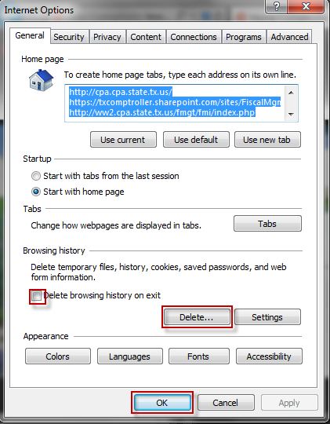

- Then select Delete.

- The Delete History Dialogue box will pop up. Ensure the following items are selected:

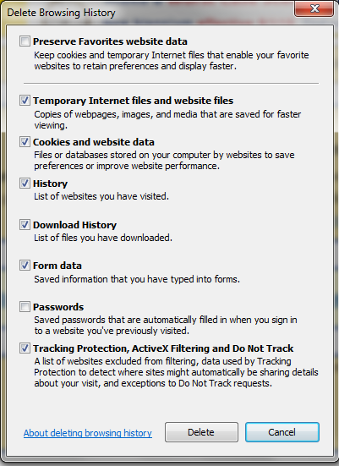
- Temporary Internet files and website files
- Cookies and website data
- History
- Download History
- Form Data
- Tracking Protection, Active X Filtering and Do Not Track

Note: It’s important that the user does not have “Preserve Favorites website data” option checked.

Leaving this box checked means the user is not completing clearing their cache.

- Then select Ok.

- Done.

Google Chrome
The following are instructions for clearing browser cache if you are using Google Chrome.

- Click the 3 dots on the right hand side of your Google Chrome window.

- Roll your mouse over the History option.

- On the pop out menu select History.

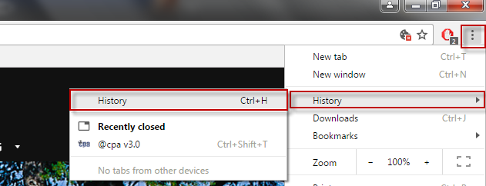

- A new “History” tab will appear, on the left hand side select Clear browsing data.

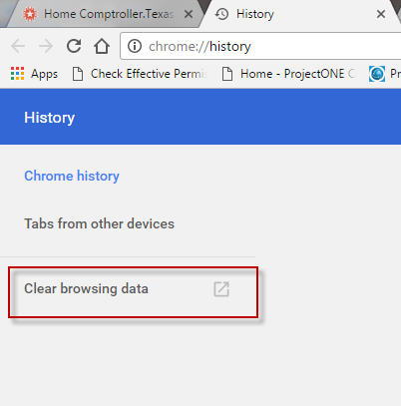

- A new “Settings – Clear browsing history” tab will display, with a “clear browsing history” dialogue box already open in the middle of the page.

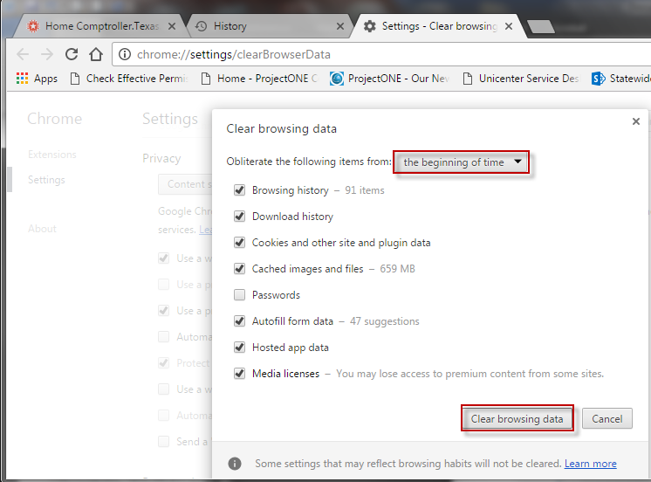

- Ensure the “Obliterate the following items from:” is set to the beginning of time.

- Ensure the following check boxes are checked:
  - Browsing history
  - Download history
  - Cookies and other site and plugin data
  - Cached images and files
  - Autofill form data
  - Hosted app data
  - Media licenses

- Select Clear browsing data.

- Done.

Internet Explorer Settings
If using Internet Explorer, the following are recommended settings for use with the new PeopleTools 8.55.

- Access your Tools menu, by clicking it from your Browser Menu Bar or by clicking on the Tools “Cog” in the top right corner of the window.
- Select Internet Options.
- Under the “Advanced” tab, ensure the following checkboxes are “checked”:
- Use software rendering instead of GPU Rendering
- Do not save encrypted pages to disk
- Empty Temporary Internet Files Folder when browser is closed
- Use TLS 1.2

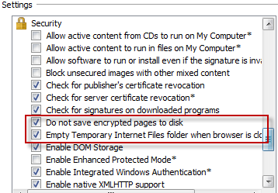

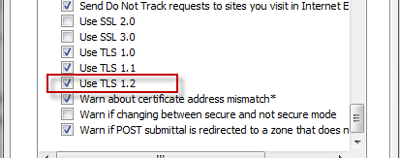

- Done.

User sees Blank Screen

Issue: In the event you see the CAPPS Home Screen but do not have any buttons available.

Fix: Users can correct this issue by hitting the “Home” button in the top right corner of the screen. This error is an uncommon error that was found very intermittently during testing

BEFORE:
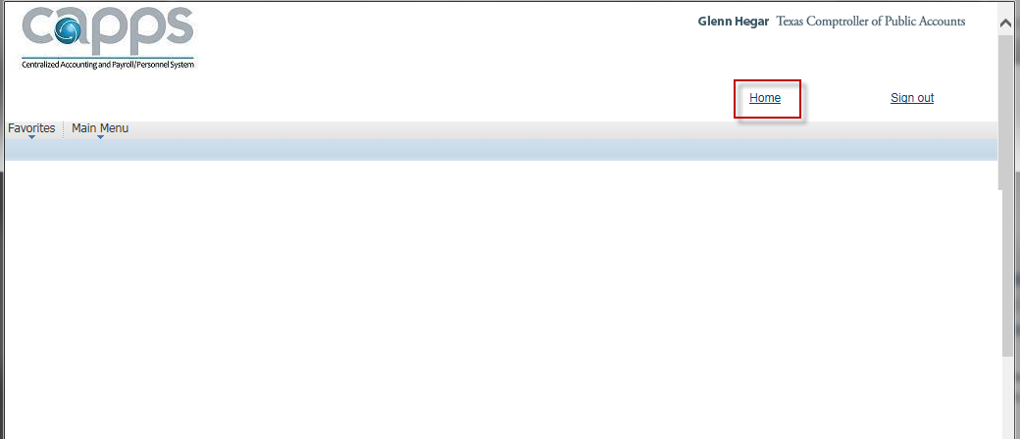

AFTER:
