# 



CAPPS Recruit Hiring Manager Desk Aid

Texas Military Department

September 2018

Table of Contents

**Section 1 – TMD Hiring Process** 3

1. State Employee Hiring Process Overview 3

2. Request to Post a Job Vacancy 4

a. HR Screening 6

b. Reviewing Referred Applications 6

c. Supervisor Secondary Screening 6

d. Conducting Interviews 6

e. Selection Process and Job Offer 6

**Section 2 – CAPPS Recruit Navigation** 8

1. Logging In and Password Reset Instructions 8

2. Navigation Fundamentals 11

3. Online CAPPS Recruit Training 13

**Section 3 – Hiring Manager/Approver Actions Required in CAPPS Recruit** 14

1. Approve/Reject Requisition (Job Posting) 14

a. Responding to the Email request 14

b. Using the Tasks Channel and Tasks List method 14

2. Review Candidate Files (State Application) 14

3. Print Candidate Files (State Application) 17

4. Approve/Reject Request for Job Offer 20

a. Responding to the Email request 20

b. Using the Tasks Channel and Tasks List method 24

**Section 4 – Appendix** 27

1. CAPPS HR/PAYROLL Recruiting Icons list 27

2. Request to Post a Job Vacancy form 28

3. Job Description template 29

4. Secondary Screening Matrix template 30

5. Scoring Matrix template 31

# **Section 1 – TMD Hiring Process**

## **State Employee Hiring Process Overview**

With the implementation of CAPPS Recruit, the hiring process will require the Hiring Manager and/or Approver(s) to complete certain steps in CAPPS Recruit. Some steps, such as the Request to Post a Job, will be completed outside of the CAPPS Recruit system. Other steps, such as Approving the Job Posting (or Requisition), screening state applications (known as the Candidate File) and Approving the Job Offer will be completed in CAPPS Recruit. Please review the following process overview:

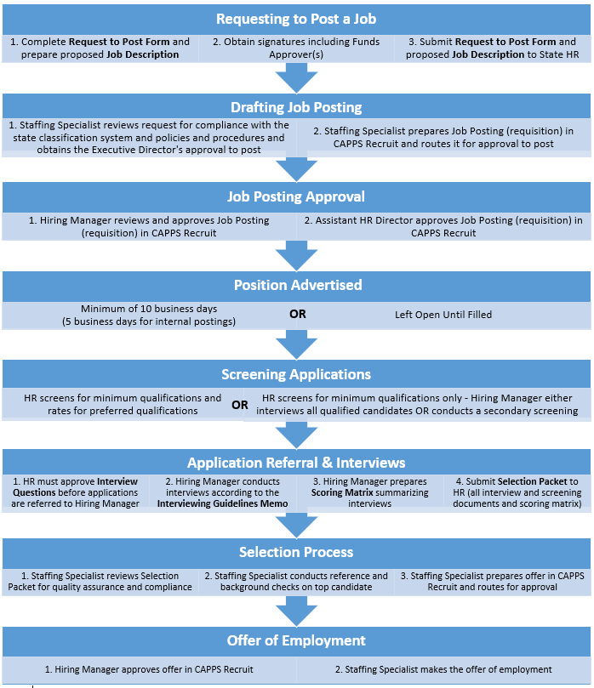

## **Request to Post a Job Vacancy**

To fill a new position or vacancy, complete the Request to Post Job Vacancy form.

**Procedure**

| **Step** | **Action** |
| --- | --- |
|  | The Request to Post a Job Vacancy form can be found in the Appendix and on the TMD website at:  [www.tmd.texas.gov](http://www.tmd.texas.gov) > Resources >TMD forms > State Human Resources > Request to Post Job Vacancy **OR**  <https://tmd.texas.gov/capps> > Forms > Request to Post Job Vacancy form. |

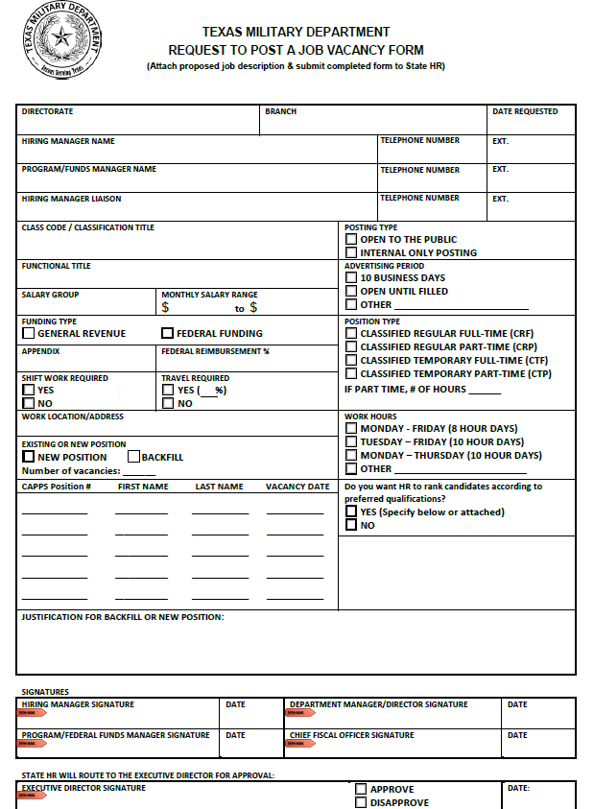

| **Step** | **Action** |
| --- | --- |
|  | The completed Request to Post a Job Vacancy form and a proposed job description should be submitted by the Hiring Manager to State Human Resources (HR).  Refer to Appendix for forms |
|  | The HR Staffing Specialist reviews the Job Posting request for compliance with the State Classification system, policies and procedures and obtains Executive Director’s approval to post. |
|  | Once the Job Posting is approved by Hiring Manager in CAPPS Recruit, the Assistant HR Director will review and approve the Job Posting in CAPPS Recruit. |
|  | After approval by the Assistant HR Director, the Job Posting (Requisition) is posted and advertised through CAPPS Recruit by the HR Staffing Specialist. |

1. **Interview and Selection Process**
2. **HR Screening**

Once the Job Posting is advertised by State Human Resources (HR) and candidate applications are received, HR will screen the applications for minimum qualifications. State HR may also screen the applications for preferred qualifications, if desired by the Hiring Manager.

The Hiring Manager must submit interview questions for review and approval by the HR Staffing Specialist. After the interview questions are approved, and all applications are screened, State HR will refer candidates to the Hiring Manager through CAPPS Recruit and provide the Hiring Manager with a list of referred candidates and a Hiring Guidelines memo.

1. **Reviewing Referred Applications**

The Hiring Manager will review the applications in CAPPS Recruit (and can print the applications, if desired).

**Refer to Section 3, Step 2: Review Candidate Files (State Application)**

**Refer to Section 3, Step 3: Print Candidate Files (State Application)**

1. **Supervisor Secondary Screening**

If the Hiring Manager does not want to interview all referred candidates, the Hiring Manager may conduct a secondary screening outside of CAPPS Recruit using the list of referred candidates provided by State HR. The Secondary Screening Matrix and analysis must be submitted to State HR with the Selection Packet. Contact State HR for questions or assistance when completing a secondary screening.

**Refer to Appendix 4: Secondary Screening Matrix template**

1. **Conducting Interviews**

Once the applications have been reviewed and secondary screening is conducted (if necessary) to identify the candidates for interviews, the Hiring Manager will schedule and conduct interviews outside of CAPPS Recruit in accordance with the instructions in the Hiring Guidelines Memo.

1. **Selection Process and Job Offer**

Once interviews are conducted, the Hiring Manager will notify State HR of the selected candidate(s) for hire and the job offer information by returning the completed Selection Packet, including the scoring matrix, interviewing notes, and secondary screening matrix (if applicable). Refer to the Hiring Guidelines Memo for additional instructions.

Once received, State HR will review and audit the Selection Packet and will complete reference checks and criminal background checks, if applicable. After State HR has completed these pre-offer steps, State HR will coordinate with the Hiring Manager to create a job offer in CAPPS Recruit and route the job offer for approval by the Hiring Manager and other Approver(s), as appropriate.

Once the job offer is routed for approval in CAPPS Recruit, an email will be sent to the Hiring Manager and/or Approver(s) when their action is required in the system. It is important for the Hiring Manager and/or Approver(s) to review all the details of the job offer before approving the job offer. If there are issues with the job offer or changes needed, please contact the HR Staffing Specialist before rejecting a job offer.

**Refer to Section 3, Step 4: Approve/Reject Request Job Offer**

Once the job offer is approved in CAPPS Recruit, the HR Staffing Specialist will make the offer of employment to the candidate(s). If the candidate(s) negotiate the offered salary, the HR Staffing Specialist will coordinate with the Hiring Manager for the final job offer and make the necessary adjustments to the job offer in CAPPS Recruit.

# **Section 2 – CAPPS Recruit Navigation**

1. **Logging In and Password Reset Instructions**

Your CAPPS Recruit User Name will be the same as your CAPPS User ID (000100XXXXX), however the passwords are separate. You will be required to update your CAPPS Recruit password every 90 days. Your password must be at least 8 characters and include an uppercase letter, number and special character.

You can login directly to the CAPPS Recruit User Sign In page at: <https://capps.taleo.net>

Or, you can login to CAPPS at: <https://entprtlprd.cpa.texas.gov/> and select the gray CAPPS Recruit button on your homepage. This will take you to the CAPPS Recruit User Sign In page referenced above.

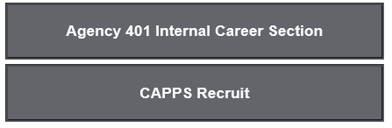

NOTE: The Agency 401 Internal Career Section button from your CAPPS home page will take you to a current list of TMD state job postings.

| **Step** | **Action** |
| --- | --- |
| 1. | Before logging in, you will see the Legal Agreement page. You will see this each time you log in and when your system times out after no activity. |
| 2. | The language defaults as English. Do not change the language. |

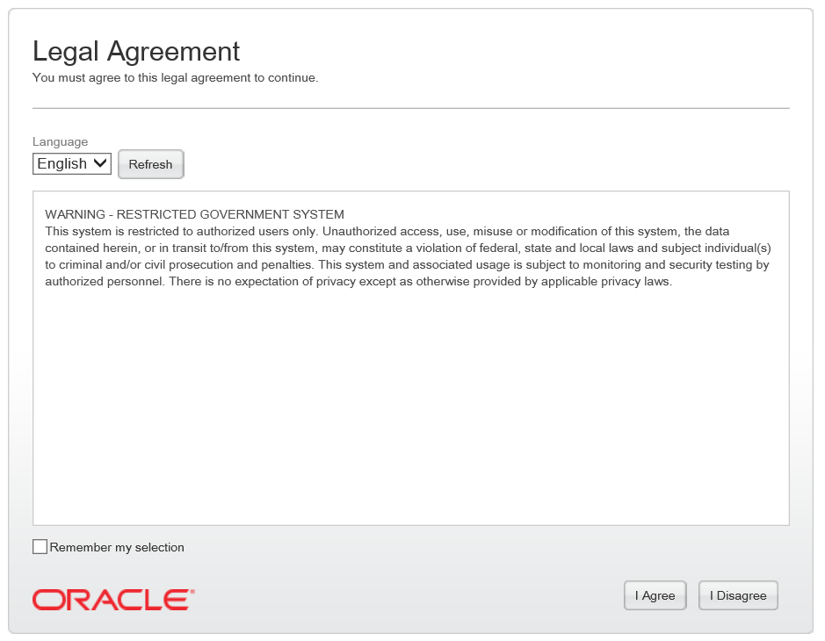

| **Step** | **Action** |
| --- | --- |
| 3. | Click the **I Agree** button. |

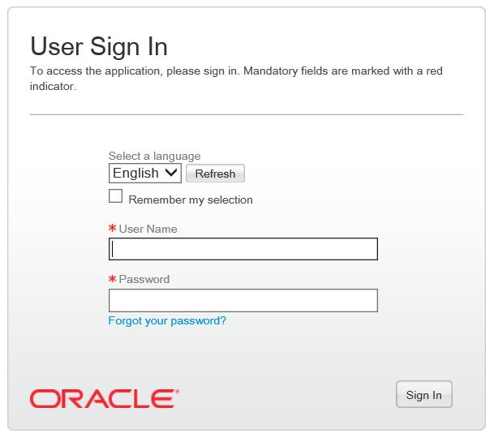

| **Step** | **Action** |
| --- | --- |
| 4. | When you reach the User Sign in screen, enter your **User Name. This is the same as your CAPPS user ID number.** |
| 5. | Enter your **Password.** **You have a separate password for CAPPS Recruit**.    **NOTE:** It is recommended that if you have 3 failed attempts when trying to login, use the Forgot Password feature to have your password reset.  **After 5 failed attempts, you will be “locked out” of CAPPS Recruit** and you must contact Statewide Fiscal Systems Security at: [sfs.security@cpa.texas.gov](mailto:sfs.security@cpa.texas.gov) to unlock your account. State HR will NOT be able to unlock your account. |
| 6. | Click the **Sign In** button. |

1. **Navigation Fundamentals**

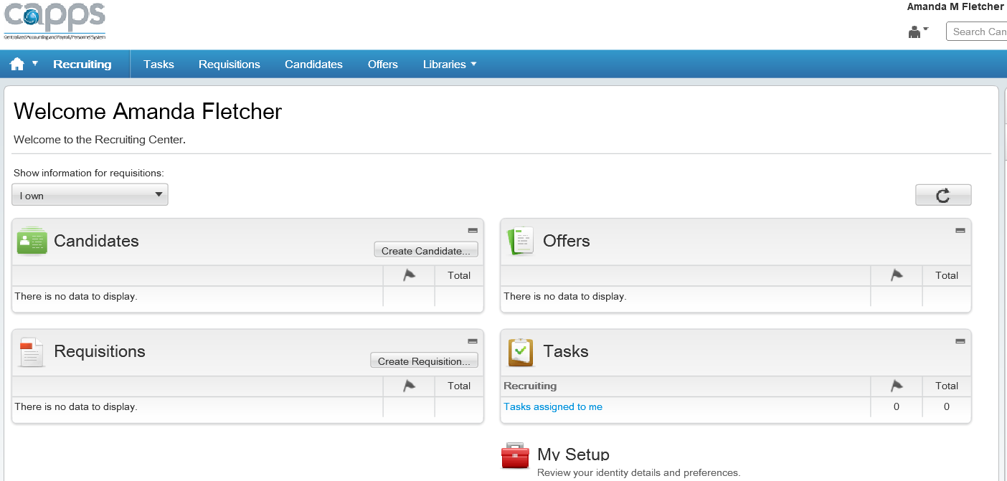

Core Navigation Bar

Channels

|  |  |
| --- | --- |
| 1. | The **Recruiting Home Page** displayed aboveis the page users will see when they first log into **CAPPS Recruit.** There are four primary sections including Candidates, Requisitions, Offers and Tasks. These are displayed and can be accessed in two different ways called the **Channels** in the center and the **Core Navigation Bar** at the top.  Note: The other links available to you are determined by your security role. |
|  | At the top righthand corner, the **Auxiliary Navigation Bar** contains **Home, Resources (My Setup),** **Sign Out** and **Quick Search**.  **Home** relaunches the application and brings you back to the **Recruiting Home Page**.    **User Name** |
|  | The **Quick Search** feature gives the option to change from **Search Candidate** to **Search Requisition**. |
|  | The **Channels** in the center of the **Recruiting Home Page** display status-oriented data about a user's activities. For example, this will show the total number of tasks assigned to the user such as offers and requisitions pending approval. |
|  | The links on the **Core Navigation Bar** also appear within the **Channels** below.  Both links will take you to the same place. |

| **Step** | **Action** |
| --- | --- |
|  | Click the **Tasks** link in either the **Core Navigation Bar** or the **Channel**.  Tasks are activities that are performed by users in CAPPS Recruit.  This section contains the **Task List**.  It displays the Tasks and the corresponding Candidate and/or Requisition.  Access/execute the Task by clicking on the Task name. |
|  | **Quick Filters** help to narrow down the list of tasks displayed in the **Task List**. This may also help to locate tasks with a specific status. |
|  | Under **Show tasks for requisitions**, depending on your access, you can view filter tasks by the following:  - Requiring attention  - Hide completed tasks  - Due Date  - Task Type  - Related to Candidate/Requisition/Assignee  If you ever find that the task list should contain more or less information, check the **Quick Filters** settings. |
| **NOTE: You will have similar navigation and Quick Filters for viewing Requisitions, Candidates, and Offers.** | |

1. **Online CAPPS Recruit Training**

To learn more about the navigation and functionality of CAPPS Recruit, you may complete the CAPPS HR/Payroll Agency Recruiting (115) Online Course at <http://cappstraining.cpa.texas.gov/courses/HR/115_AR/index.php>

# **Section 3 – Hiring Manager/Approver Actions Required in CAPPS Recruit**

1. **Review Candidate Files (State Application)**

**Candidate File**

A candidate file is a form containing candidate information such as personal information, work experience, certifications, references and screening information. The candidate file is more commonly known as the State Application.

**Candidates List**

The candidates list displays the list of referred candidates by requisitions, summary candidate file information and provides tools to filter candidates and to customize the candidates list.  **Candidates will only appear in the list if they are attached to a requisition and referred by State HR.**

NOTE: You may see some candidate files are designated as ACE Candidates with a star icon  . This alerts you that the candidate has indicated they have all of the abilities, certifications and experience that are required and preferred for the position. However, these may not be supported in the application so it’s important that you do not rely solely on this designation when selecting candidates to interview.

The following steps show how to view a candidates list and the details of a candidate file.

| **Step** | **Action** |
| --- | --- |
| 1. | Below is the **CAPPS Recruiting Home Page**.  You can view candidate lists and candidate files by clicking on the **Candidates Channel** in the center of the homepage or the **Core Navigation Bar** at the top. |

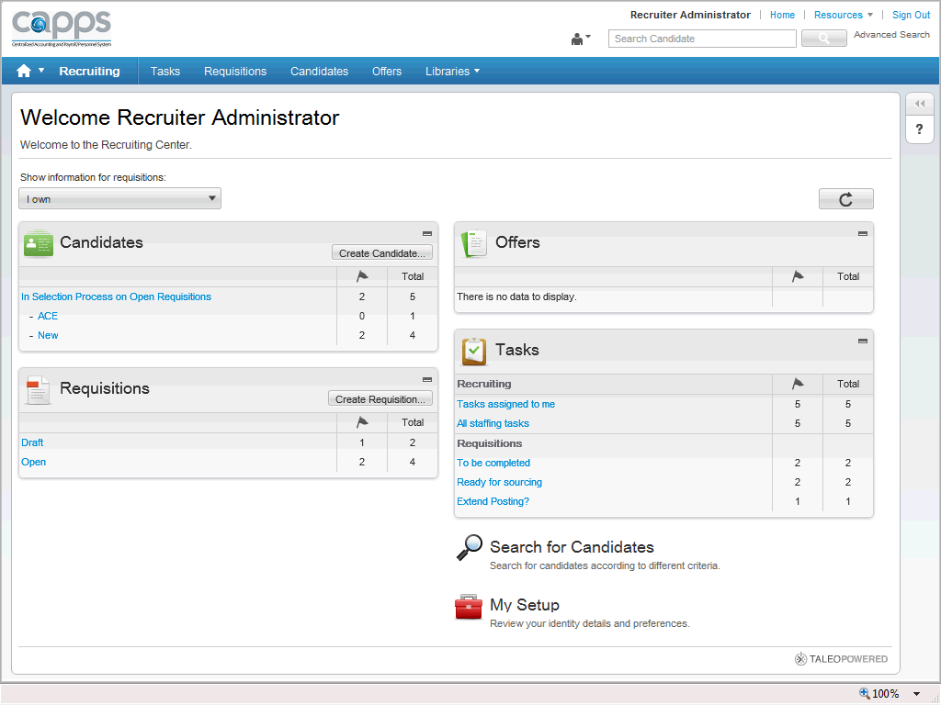

| **Step** | **Action** |
| --- | --- |
| 2. | Click the **Candidates** link to access the candidates list. |
| 3. | The **Candidates** page is used to list, search and view candidate details. |
| 4. | Notice **all** candidates attached to a requisition are listed by requisition number.  Only candidates attached to a requisition and referred by State HR will be displayed.  Use the **Horizontal Scrollbar** at the bottom of the page to see the full view. |

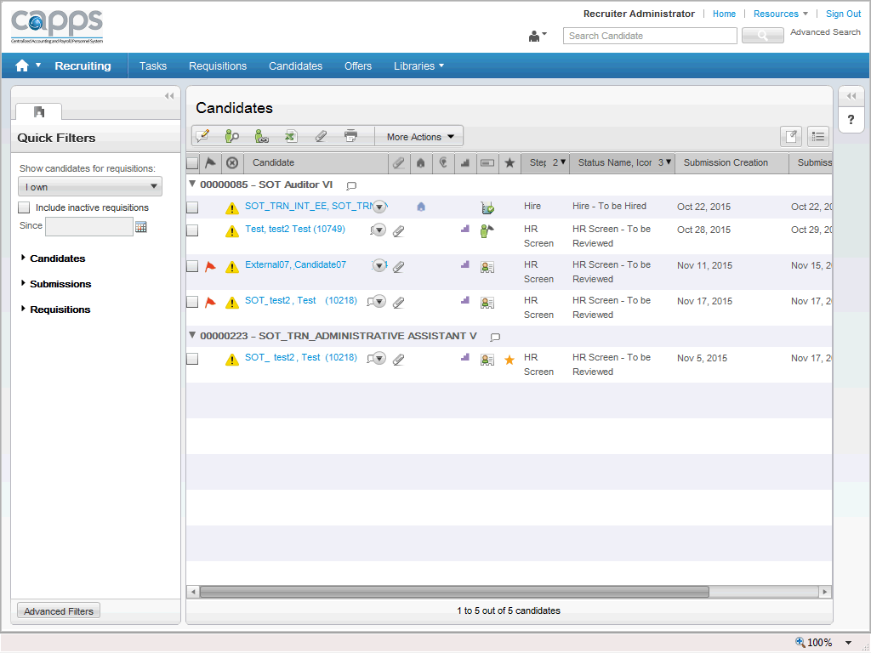

| **Step** | **Action** |
| --- | --- |
| 5. | The **Quick Filters** panel to the left provides the ability to sort and filter the candidates based on **Candidate**, **Submissions** and **Requisitions** detail. |
| 6. | Click the **candidate’s name** to view the candidate’s details. |

| **Step** | **Action** |
| --- | --- |
| 8. | You will see four tabs across the top of the candidate file: Job Submission, Attachments, Tasks and History. The main content of the candidate file is within the **Job Submission** tab. |
| 9. | The requisition (job posting) for which the candidate applied is identified at the top of the page. |

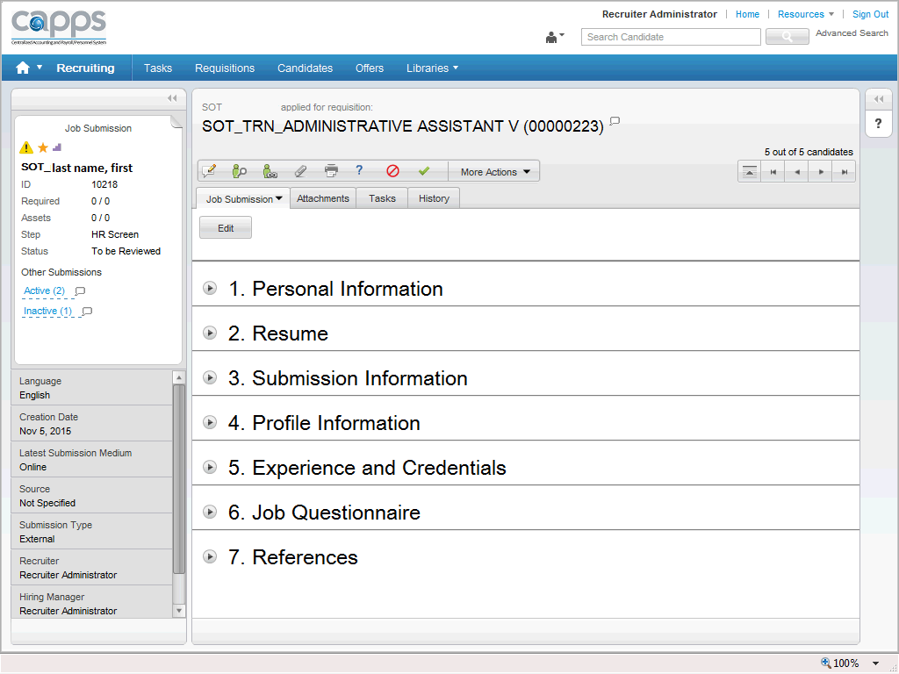

| **Step** | **Action** |
| --- | --- |
| 11. | Each Candidate file’s **Job Submission** section expands to view their application details related to:  - Personal Information  - Resume  - Submission Information  - Profile Information  - Experience and Credentials  - Job Questionnaire  - References  Click  to expand the area you wish to view. |
| 12. | Click on the **Attachments** tab to view additional information submitted by the candidate. |

1. **Print Candidate Files (State Application)**

The print functionality in CAPPS Recruit allows users to create a PDF version of a requisition file (job posting) or a candidate file (state application) for printing.

The print function is available in the Candidates list and within Candidate files. When using the print function, users can decide to print a summary listing of candidates or requisitions, or they can choose to print the details of the file where content is presented into sections.

**NOTE:**  A maximum of 1000 lines can be printed in the list. Within the .pdf file that is created, there is an option to Save and/or Print the file.

The following steps show how to print a **Candidate File**.

| **Step** | **Action** |
| --- | --- |
| 1. | Below is the **CAPPS Recruiting Home Page**.  You can view candidate lists and candidate files by clicking on the **Candidates Channel** in the center of the homepage or the **Core Navigation Bar** at the top. |
| 2. | To print a candidate's file, access the **Candidates** section of the Recruit home page. |

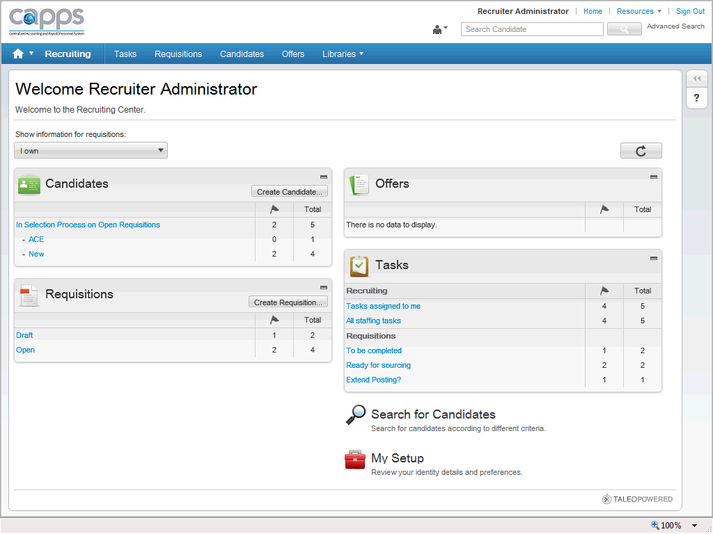

| **Step** | **Action** |
| --- | --- |
| 4. | The **Candidates** page displays a list of referred candidates sorted by requisition. |
| 5. | Click the **candidate’s** name you want to print to view their candidate file. |
| 6. | The detail of the candidate's file is displayed. |
| 7. | Click the **Printer** icon  and the **Print Configuration** page will display. |

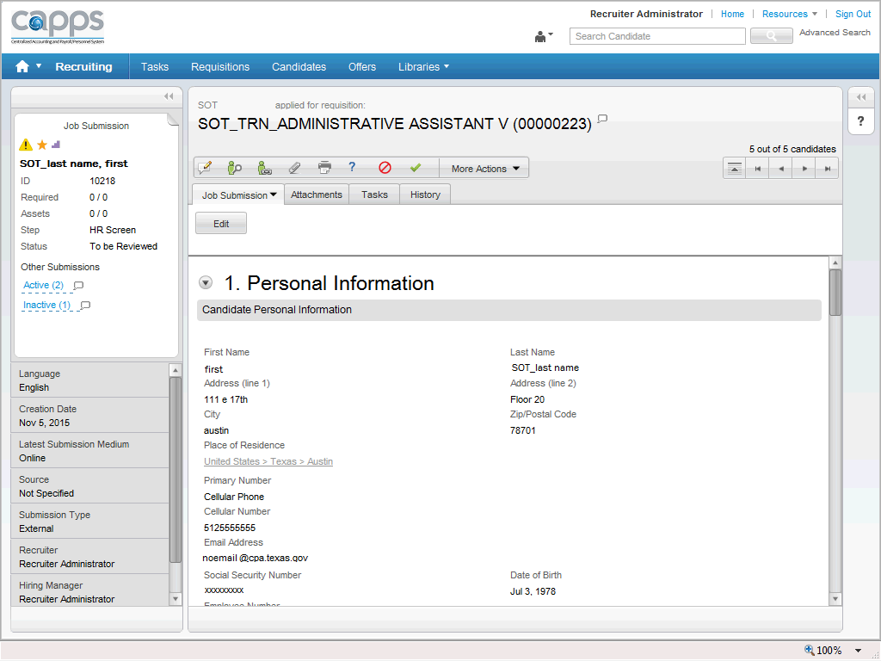

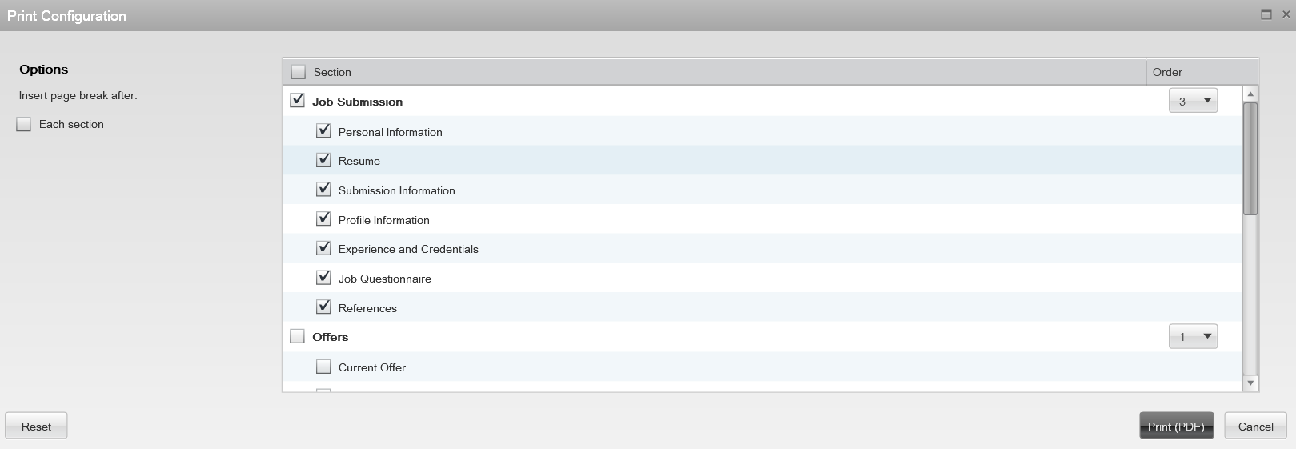

| **Step** | **Action** |
| --- | --- |
| 8. | The **Print Configuration** page provides options to print selected items from the candidate's file.  Click the scrollbar to scroll down and view additional information that may be printed from the candidate's file. |
| 9. | Based on the desired printout, a user may click the appropriate section checkbox(es).  **NOTE:**  At least one section must be checked to print candidate information.  TIP: When printing the selected candidate’s application for interviews, uncheck the following:   * Offers * History |
| 10. | Before printing, you may also select the order in which you want the sections printed on the right side of the **Print Configuration** page. |
| 12. | When you have the sections and the order set how you would like to print, click the **Print (PDF) button.** This button converts the selected data to a PDF file that can be printed or saved to your computer |
| 13. | The **Candidate Information** form is created in a PDF format.  Click the scrollbar and review the document before printing. |



## **Approve/Reject Request for Job Offer**

Once the Hiring Manager selects the final candidate and provides State HR with the Selection Packet and job offer details, State HR will prepare the Job Offer in CAPPS Recruit.

State HR will then Request Approval from the Hiring Manager and other Approvers(), as appropriate. The Hiring Manager and Approver will receive an email when their action is required.

The Hiring Manager and Approver(s) can complete the Approve/Reject Job Offer task two different ways:

a. By clicking “**Respond**” in the email sent from State HR through CAPPS Recruit; or

b. By logging into CAPPS Recruit and going to **Offers** task using the **Tasks Channel/Tasks List** method.

1. **Responding to the Email request**

| **Step** | **Action** |
| --- | --- |
| 1. | You will receive an email from [capps.recruiting@cpa.texas.gov](mailto:capps.recruiting@cpa.texas.gov) with an Offer Approval Request.  **NOTE: The email will appear like the following if you are on a non-DoD network.** If you receive an email through the DoD network, the active link **Respond…** will be disabled. You can copy and paste the URL address to a Web browser to login to CAPPS Recruit and continue the process. |

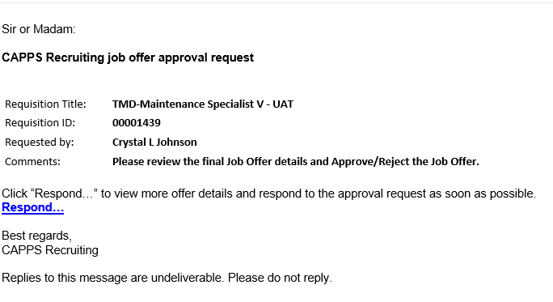

| **Step** | **Action** |
| --- | --- |
| 2. | Click the **Respond** link. |
| 3. | Login into CAPPS Recruit using your CAPPS user ID number and CAPPS Recruit password. |
| 4. | The **Offer Approval Request** screen appears.  To move down the page, click the **Vertical Scrollbar**. |

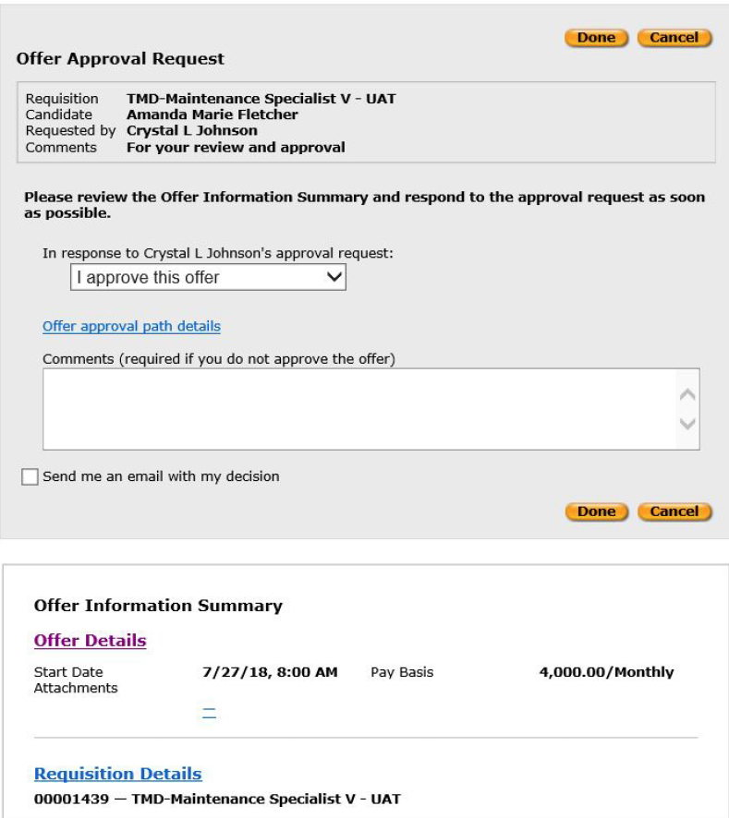

| **Step** | **Action** |
| --- | --- |
| 5. | Carefully review the full **Offer Details** and **Requisition** **Details** prior to Approving or Rejecting an Offer.   * Click the **Offer Details** link. * Click the **Requisition Details** link.   There may be multiple pages to review. Click the **Vertical Scrollbar** to move through the pages.  After reviewing each screen, click the X at the top to close the page. |
| 6. | After you have reviewed and closed the **Offer Details** and **Requisition** **Details**, you should be back to the **Offer Approval Request** screen. |



| **Step** | **Action** |
| --- | --- |
| 7. | You can either Approve or Reject this Offer.  **NOTE:**  The **"I approve this offer"** option is the default and will automatically populate in this field unless you change it.  To Approve, click the **I approve this Offer** list item.    The alternate option is, **I reject this offer,** should you find a discrepancy in the Offer. **Before rejecting the Offer, please contact the HR Staffing Specialist for further instructions.** |
| 8. | **Comments** can be entered but are not required unless you are Rejecting the Offer.  If the initial salary you are offering is negotiable, it’s recommended you include details about your maximum salary offer in the comments. |
| 9. | If you would like an email of your decision sent to you,  Click the **Send me an email with my decision** option. |
| 10. | To save your response,  Click the **Done** link. |
| 11. | Click the **Exit** link. |

1. **Using the Tasks Channel and Tasks List method**

The Hiring Manager or Approver can complete the Approve/Reject Offer process using the Tasks Channel and Tasks List method in CAPPS Recruit.

| **Step** | **Action** |
| --- | --- |
| 1. | Login into CAPPS Recruit using your CAPPS User ID number and CAPPS Recruit Password. |

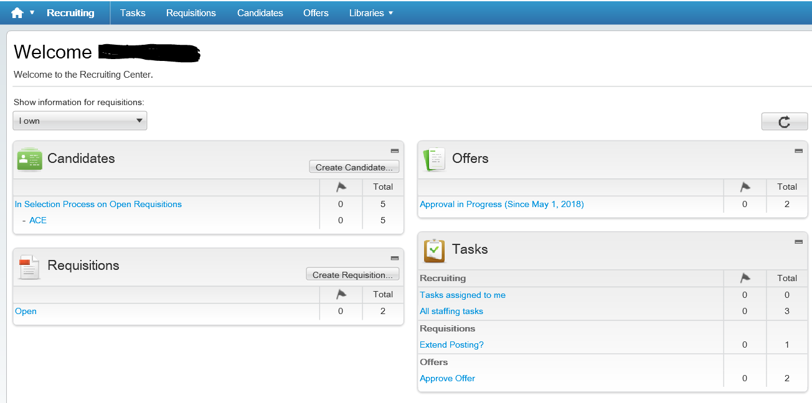

| **Step** | **Action** |
| --- | --- |
| 2. | You will know through the **Tasks Channel** if an Offer is awaiting your Approval. |
| 3. | Click **Approve Offer** link and you will be directed to the Task list. |
| 4. | From the Tasks list,  Click on the **Approve Offer** link next to the candidate’s name. |
| 5. | Carefully review the full **Offer** **Details** and **Requisition** **Details** prior to Approving or Rejecting an Offer.  You will find the Offer details on the left side of the page toward the bottom.   * Click the **Offer Details** link. * Click the **Requisition Details** link.   There may be multiple pages to review. Click the **Vertical Scrollbar** to move through the pages.  After reviewing each screen, click the X at the top to close the page. |
| 6. | After you have reviewed and closed the **Offer Details** and **Requisition** **Details**, you should be back to the **Offer Approval Request** screen. |
| 7. | Click the **Decision** list item. This is the field where you will Approve or Reject an **Offer.**    **NOTE:** The “**Approve**” option is the default and it will automatically populate this field unless you change it.  The alternate option is **“Reject”** should you find a discrepancy in the Offer.  **Before rejecting the Offer, please contact the HR Staffing Specialist for further instructions.** |
| 8. | **Comments** can be entered but are not required unless you are Rejecting the Offer.  If the initial salary you are offering is negotiable, it’s recommended you include details about your maximum salary offer in the comments. |
| 9. | If you would like an email of your decision,  Click the **Checkbox** option. |
| 10. | To Save your response,  Click the **Done** link. |
| 11. | Click the **Exit** link. |

# **Section 4 – Appendix**

1. CAPPS HR/PAYROLL Recruiting Icons list

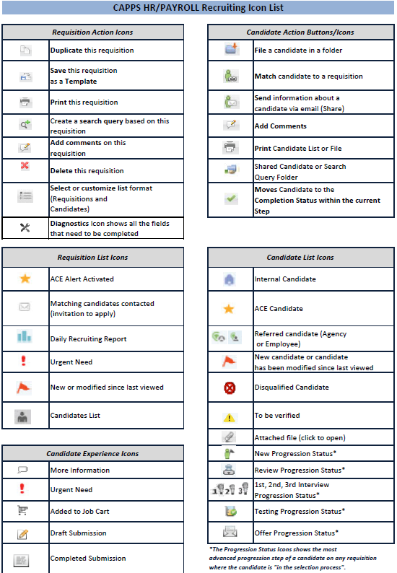

2. Request to Post a Job Vacancy form



3. Job Description template

**STATE CLASSIFICATION JOB TITLE**

**(Functional/Working Job Title)**

**BRIEF POSITION SUMMARY**

*Give a brief description of the position including degree of complexity, level of supervision required and degree of latitude for use of initiative and independent judgment.*

**ESSENTIAL JOB FUNCTIONS AND RESPONSIBILITIES**

*List the primary duties and responsibilities of the position (not every task).*

**MINIMIUM QUALIFICATIONS**

*List required education.*

*List required experience.*

*(NOTE: Check with HR for standard qualifications for each classification)*

**PREFERRED QUALIFICATIONS**

*List any preferred education and experience, if any.*

**REGISTRATION, CERTIFICATION OR LICENSURE**

*List any required or preferred registrations, certifications or licenses, if any.*

**KNOWLEDGE, SKILLS AND ABILITIES**

*List knowledge, skills and abilities necessary for the position.*

**PHYSICAL/WORKING CONDITIONS**

*Provide a description of the physical and working conditions of the position.*

I acknowledge that my responsibilities have been communicated to me and I understand my role within the Texas Military Department.

**_____________________**

Employee Signature Date

**_____________________**

Supervisor Signature Date

***The duties and responsibilities of your job may significantly impact the environment. You are responsible to maintain awareness of your environmental responsibilities as dictated by legal and regulatory requirements, your organization, and its changing mission.***

4. Secondary Screening Matrix template

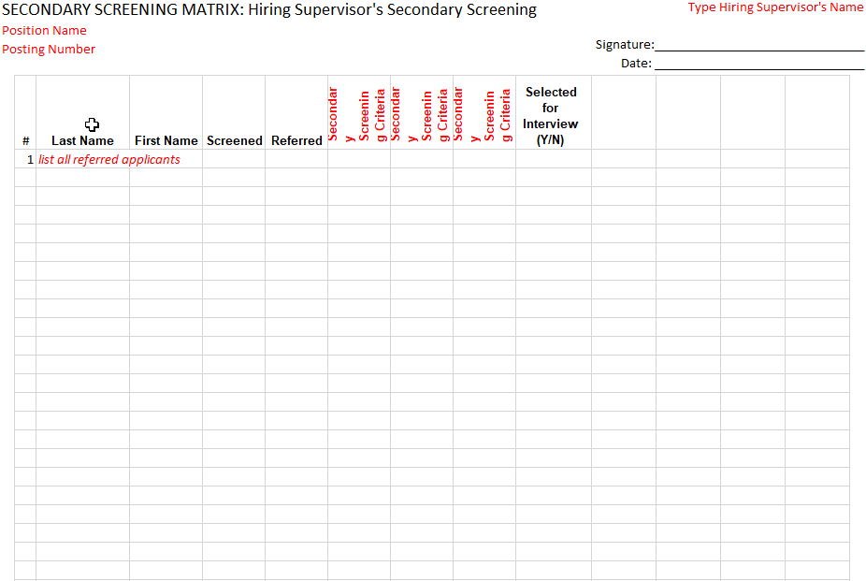

5. Scoring Matrix template

